ACI Worldwide: Intern Technical Consultant
Submitted at the end of semester VIII in partial fulfillment of requirements
For the degree of
Bachelors of Technology
In
Department / Programme Name
by
Name of the Student
Roll No.:

Mentor
Name of the Internal Mentor
Name of the External Mentor

K. J. Somaiya School of Engineering

Batch 2022 -2026

Certificate

This is to certify that the Internship report entitled ________ (Title of the Internship) completed at _____________ (Name of Organization) during __________ (duration of Internship) submitted by ______________(Name of the Student) at the end of semester VIII of LY B. Tech is a bona fide record for partial fulfillment of requirements for the degree of Bachelors in Technology in Electronics Engineering of Somaiya Vidyavihar University.

____________________ _____________________ Internship Internal Mentor Internship External Mentor

___________________
Head of the Department

_________________
Director

Date:
Place: Mumbai

Certificate of Approval of Examiners

We certify that this Internship report entitled __________________ (Internship Title) is bona fide record of internship work done by ______________ (Name of the Student) during semester VIII.
This internship work is submitted at the end of semester VIII in partial fulfillment of requirements for the degree of Bachelors in Technology in Electronics Engineering of Somaiya Vidyavihar University.

___________________________
Internal Mentor

____________________________
External/Internal Examiners

Date:
Place: Mumbai

DECLARATION
I declare that this written internship report submission represents the work done based on our and / or others’ ideas with adequately cited and referenced the original source. I also declare that I have adhered to all principles of intellectual property, academic honesty and integrity as we have not misinterpreted or fabricated or falsified any idea/data/fact/source/original work/ matter in my submission.
I understand that any violation of the above will be cause for disciplinary action by the college and may evoke the penal action from the sources which have not been properly cited or from whom proper permission is not sought.

______________________________
Signature of the Student

_______________________________
Roll No.

Date:
Place: Mumbai

Internship Completion Certificate
(Certificate received by Organization can be attached here)

Abstract
This report documents the Semester-Long Internship undertaken at ACI Worldwide as an Intern Technical Consultant. The internship focused on two core enterprise platforms: the Universal Payments Framework (UPF) and the Proactive Risk Manager (PRM). UPF is ACI's foundational payments integration framework that provides the architectural backbone necessary to build, deploy, and operate payment solutions integrating ACI products with external systems including banks, merchants, billers, card processors, and intermediaries. PRM is ACI's enterprise-level fraud detection and risk management platform used by financial institutions worldwide to monitor transactions across all payment channels in real time and near real time, applying rules, velocity checks, behavioral profiling, and machine learning scoring to detect suspicious activity. The internship combined conceptual learning with system analysis and practical development exposure, covering end-to-end payment processing lifecycles, UPI Pay and Collect API flows, PRM's four-layer architecture, and UPF's multi-tier deployment model. Together, UPF and PRM address two fundamental and complementary challenges in the payments industry: reliably processing transactions at high speed and scale, and ensuring fraudulent transactions are identified and stopped before or shortly after they occur.

Key words: Universal Payments Framework (UPF), Proactive Risk Manager (PRM), ACI Worldwide, Real-Time Payments, Fraud Detection, Payment Switch, ISO 8583, ISO 20022, Machine Learning Scoring, Microservices, UPI, Near-Real-Time Analytics, Cartridge, Configuration Builder, Scoring Engine
Table of Contents
List of Figures |  |  | Viii
List of Tables |  |  | Viii
Nomenclature |  |  | IX
1 | Introduction |  | 1
 | 1.1 | Background of Industry | 1
 | 1.2 | Motivation | 2
 | 1.3 | Scope of the Internship | 3
 | 1.4 | Brief description of work undertaken | 4
 | 1.5 | Organization of the report | 4
2 | Concept of the Internship |  | 6
 | 2.1 | Conceptual Background of the Internship | 6
 | 2.2 | Literature Survey | 6
 | 2.3 | Objectives | 7
 | 2.4 | Methodology | 8
3 | Flow diagram / Methodology |  | 10
 | 3.1 | UPF Transaction Processing Flow | 10
 | 3.2 | Problem statement | 10
 |  | 3.2.1 UPF Architectural Challenges | 10
 |  | 3.2.2 PRM Fraud Detection Challenges | 11
 | 3.3 | System diagram | 11
 |  | 3.3.1 UPF System Architecture | 11
 |  | 3.3.2 PRM Component Architecture | 14
 | 3.4 | Objectives | 17
4 |  | Implementation and experimentation | 19
 | 4.1 | UPF Implementation | 19
 | 4.2 | PRM Fraud Detection Testing and Analysis | 20
 |  | 4.2.1 Rule Testing | 20
 |  | 4.2.2 Scoring Engine | 22
 |  | 4.2.3 Alert Handling | 23
 |  | 4.2.4 System Integration | 23
5 | Key Learnings from the Internship |  | 25
 | 5.1 | Technical Learnings from UPF | 25
 | 5.2 | Technical Learnings from PRM | 26
6 | Results and Conclusions |  | 28
 | 6.1 | Results | 28
 | 6.2 | Conclusion | 29
Appendix A |  |  | 32
Acknowledgements |  |  | 33

List of Figures
1 | UPF Multi-Tier Architecture | 13
2 | PRM Workflow - RT and NRT flows | 16
3 | PRM Architecture | 17

List of Tables
1 | UPF Supported Communication Protocols | 12
2 | UPF Traditional vs Cloud-Native Deployment Models | 19
3 | PRM Rule Categories and Descriptions | 21
4 | PRM Scoring Engine Types - PSE vs USE | 22

Nomenclature

UPF | Universal Payments Framework
PRM | Proactive Risk Manager
ACI | ACI Worldwide
UPI | Unified Payments Interface
NPCI | National Payments Corporation of India
RT | Real-Time
NRT | Near Real-Time
PSE | PRM Scoring Engine
USE | Universal Scoring Engine
POS | Point of Sale
ATM | Automated Teller Machine
ACH | Automated Clearing House
ISO | International Organization for Standardization
REST | Representational State Transfer
JDBC | Java Database Connectivity
WAR | Web Application Archive
AR | Analysis and Review
DB | Database
A/D | Approve / Decline
ML | Machine Learning
MQ | Message Queue
SSL | Secure Sockets Layer
TCP/IP | Transmission Control Protocol / Internet Protocol
SOAP | Simple Object Access Protocol
JSON | JavaScript Object Notation
JPA | Java Persistence API
BDR | Bi-Directional Replication
HSM | Hardware Security Module
PSP | Payment Service Provider

Chapter 1
Introduction
1.1 Background of Industry
ACI Worldwide is a global leader in mission-critical, real-time payment software and solutions. Founded in 1975, ACI Worldwide serves financial institutions, intermediaries, merchants, and billers in more than 80 countries. Its platforms support thousands of financial institutions and billions of transactions annually, making it one of the most significant players in global financial technology infrastructure. ACI Worldwide is headquartered in Elkhorn, Nebraska, USA, and operates development, support, and delivery centers across multiple continents.
The internship was undertaken at ACI Worldwide's Indian operations, which form a key part of the company's global delivery and development capability. The India center contributes to the development, testing, deployment, and support of ACI's flagship enterprise payment and risk management platforms. The centre operates in close collaboration with global product teams, serving as a critical hub for technical expertise in payments technology.
ACI Worldwide's product portfolio spans payment processing, fraud management, and risk analytics. The company's flagship offerings include BASE24, a high-performance transaction switching platform used by financial institutions for ATM, POS, and card-not-present transactions; the Universal Payments Framework (UPF), a modern payment integration and orchestration platform; and the Proactive Risk Manager (PRM), an enterprise fraud detection and risk management solution. Together, these platforms serve the full lifecycle of payment transactions from initiation and routing through to settlement and fraud monitoring.
The internship centered on two core enterprise platforms developed and maintained by ACI: the Universal Payments Framework (UPF) and the Proactive Risk Manager (PRM). These two platforms together represent a comprehensive end-to-end ecosystem for processing financial transactions and managing fraud risk across the full spectrum of modern payment channels.
UPF is ACI's foundational payments integration framework. It provides the architectural backbone necessary to build, deploy, and operate payment solutions that integrate ACI products with external systems such as banks, merchants, billers, card processors, and intermediaries. UPF supports a wide range of payment types including real-time payments, retail non-card payments, and card-based or online merchant and bill payments. It is available in two deployment models: a traditional three-tier non-containerized model and a modern cloud-native Kubernetes-based containerized model.
PRM is ACI's enterprise-level fraud detection and risk management platform. Used by financial institutions worldwide, PRM monitors transactions across all payment channels — ATM, POS, online banking, mobile, ACH, wire transfers, and real-time payment networks — in real time and near real time. It applies a combination of rules, velocity checks, behavioral profiling, and machine learning scoring to detect suspicious activity, generate alerts, and route cases to fraud analysts for investigation and remediation.
Together, UPF and PRM address two fundamental and complementary challenges in the payments industry: reliably moving money between parties at high speed and scale, and ensuring that fraudulent or suspicious transactions are identified and stopped before or shortly after they occur. Understanding both platforms provides a holistic view of how enterprise financial infrastructure is designed, operated, and protected.
1.2 Motivation
The financial technology industry is undergoing an unprecedented period of transformation. The proliferation of digital payment channels — particularly in India through the Unified Payments Interface (UPI) operated by NPCI — has made real-time payments ubiquitous for consumers and businesses alike. At the same time, the dramatic growth in digital transaction volumes has created an equally dramatic growth in financial fraud, making robust fraud prevention systems not merely desirable but operationally essential.
The motivation for selecting this internship and its specific topic arises from a desire to understand how enterprise-grade financial systems are designed and operated at the intersection of high-performance distributed computing, financial regulation, and data-driven intelligence. Both UPF and PRM represent state-of-the-art implementations of these disciplines in production environments serving major banks and financial institutions globally.
From the perspective of UPF, understanding how a payment integration framework handles millions of transactions per day — ensuring message integrity, high availability, and seamless integration across dozens of external system types — provides deep insight into distributed systems architecture, protocol engineering, and enterprise software design. From the perspective of PRM, understanding how a fraud management platform scores transactions in real time, manages analyst workflows, and continuously adapts to evolving fraud patterns using machine learning provides equally deep insight into applied data science, operational analytics, and security engineering.
ACI Worldwide's global footprint and the critical nature of its platforms made this internship an exceptional opportunity to connect theoretical knowledge in computer science and engineering with real-world, mission-critical implementation challenges.
1.3 Scope of the Internship
The scope of this internship encompassed the following areas across both UPF and PRM:
- Study of the Universal Payments Framework (UPF) covering its architecture in both traditional (non-containerized) and cloud-native (Kubernetes-based containerized) deployment models; its core components including the Communication Layer, Processing Layer, Web/Service Tier, and Database; and its integration patterns with external systems including banks, billers, card processors, and merchants.
- Study of the Proactive Risk Manager (PRM) covering its four-layer architecture (Application, Data, Business Logic, Presentation), its Analytic Gateway and scoring engines (PSE and USE), its real-time (RT) and near-real-time (NRT) transaction processing flows, and its Analysis and Review (AR) microservices platform used by fraud analysts.
- Analysis of UPI payment flows — specifically the Pay API and Collect API flow diagrams — involving all participating entities including the Acquiring Channel, Payer PSP, Payee PSP, UPI, ACI Switch, Remitter Bank Core Banking, UPI HSM, and Beneficiary Bank Core Banking.
- Understanding PRM's integration with the Issuer Bank Switch and Core Banking System for real-time authorization-stage fraud intervention, and of the post-authorization NRT analytics workflow driving alert generation and analyst response.
- Review of PRM's microservices decomposition into Frontend WAR components, AR REST Backend WARs, PRM Backend WAR, and Database Server layers, including the roles of the AR DB and PRM DB (RT and NRT databases).
- Review of internal training materials, architectural diagrams, and technical documentation provided during the internship program at ACI Worldwide.
1.4 Brief Description of Work Undertaken
The work undertaken during the internship can be broadly categorized into learning and analysis activities spanning both the UPF and PRM platforms. In the UPF domain, the work involved studying the multi-tier architecture of UPF, understanding the role of each component layer, and analysing how cartridges are defined and deployed using Configuration Builder. The UPI Pay API and Collect API transaction flows were studied in depth, tracing each step and identifying the roles of all participating entities.
In the PRM domain, the work involved understanding the four-layer architecture of PRM, studying the distinction between real-time (RT) and near-real-time (NRT) processing flows, and analysing how scoring engines (PSE and USE) are integrated into the fraud detection pipeline through the Analytic Gateway. The microservices architecture of PRM's Analysis and Review platform was studied, including the Frontend WAR, AR REST Backend WARs, PRM Backend WAR, and associated databases. The internship also involved exposure to enterprise development technologies including Angular (frontend), Spring Boot, Hibernate and JPA (backend), and Groovy scripting (business logic configuration).
1.5 Organization of the Report
This report is organized into six chapters. Chapter 1 provides an introduction and motivation, including the background of the organization, the motivation for selecting the internship topic, the scope of work, and a brief description of the work undertaken. Chapter 2 presents the concept of the internship, including the conceptual background of enterprise payment systems, a literature survey of relevant foundational concepts and industry standards, and the objectives of the internship work.
Chapter 3 covers the flow diagrams and methodology, including the UPF transaction processing flow, the PRM transaction processing flows (RT and NRT), and the PRM component architecture. Chapter 4 describes the implementation and experimentation activities, covering UPF component deployment and configuration, and PRM fraud detection testing including rule testing, scoring engine analysis, alert handling, and system integration. Chapter 5 presents key learnings from the internship across both UPF and PRM domains. Chapter 6 provides the results and conclusions drawn from the internship experience, along with key conclusions in point form and future scope.

Chapter 2
Concept of the Internship
2.1 Conceptual Background of the Internship
The internship was designed to provide practical exposure to real-world enterprise payment systems with a strong focus on card and electronic payment processing. The core concept of the internship revolved around understanding how large-scale financial transaction systems operate end-to-end, from transaction initiation to authorization, clearing, settlement, and fraud monitoring.
During the internship, significant emphasis was placed on understanding the payments ecosystem, including the roles of key participants such as the issuer, acquirer, payment networks, payment switches, host systems, and core banking systems. The internship enabled a deep dive into on-us and not-on-us transaction flows, helping to understand how transactions are processed internally within the same bank as well as across different financial institutions.
A major component of the internship involved exposure to ACI Worldwide payment products, which are widely used by banks and financial institutions for real-time transaction processing. The internship focused on understanding how ACI products fit into the overall payments architecture and how they support high-volume, low-latency transaction processing environments. The learning approach combined conceptual understanding with practical exposure to product implementation and development activities, bridging the gap between academic knowledge and industry practices.
2.2 Literature Survey
A literature survey was conducted to understand the foundational concepts of electronic payment systems and card transaction processing. Modern payment systems are built on interconnected networks that facilitate secure, reliable, and near real-time transaction processing between multiple stakeholders. The payment lifecycle includes transaction initiation, authorization, clearing, and settlement, supported by standardized messaging formats such as ISO 8583 and ISO 20022.
The role of payment switches is critical in routing transactions between acquirers, issuers, and payment networks. A payment switch acts as an intermediary that validates, routes, and processes financial messages while ensuring compliance with network rules and security standards. In on-us transactions, both the issuer and acquirer belong to the same financial institution, resulting in faster processing. In not-on-us transactions, external networks such as Visa or Mastercard are involved, increasing complexity and latency.
Fraud detection and risk management form an essential component of modern payment systems. The use of rule-based engines, real-time monitoring, and behavioral analytics is fundamental to detecting fraudulent activities while minimizing false positives. Payment Risk Management (PRM) systems analyze transaction attributes such as location, transaction value, velocity, and historical behavior to identify suspicious patterns.
ACI Worldwide provides a comprehensive suite of payment solutions including BASE24, Universal Payments Framework (UPF), and Proactive Risk Manager (PRM). BASE24 is a high-performance transaction switch used by financial institutions for ATM, POS, and card-not-present transactions. UPF enables banks to process multiple payment types through a unified platform, while PRM provides real-time fraud detection and compliance monitoring.
From a software engineering perspective, enterprise payment applications are built using layered architectures and robust technology stacks. Backend systems commonly use Java-based frameworks such as Spring Boot, Hibernate, and JPA for scalability and maintainability, while frontend interfaces leverage modern frameworks like Angular for responsive user experiences. Additionally, scripting languages such as Groovy are frequently used in payment systems to implement configurable business rules and transaction logic.
2.3 Objectives
The primary objectives of the internship were as follows:
- To understand the end-to-end payment processing lifecycle and the roles of various entities involved in electronic payments, covering both UPF's transaction routing and orchestration capabilities and PRM's fraud monitoring functions.
- To gain conceptual clarity on on-us and not-on-us transaction flows and their processing mechanisms as applicable in the context of ACI payment platforms.
- To study the architecture of enterprise payment systems and how ACI products — specifically UPF and PRM — integrate within the banking ecosystem.
- To gain hands-on exposure to ACI UPF and PRM solutions at a conceptual and functional level, including their deployment models, component interactions, and integration interfaces.
- To understand fraud detection mechanisms and rule-based risk evaluation used in PRM, including the real-time and near-real-time processing flows and the dual scoring-engine model.
- To acquire practical knowledge of enterprise application development using technologies such as Angular, Spring Boot, Hibernate, JPA, and Groovy scripting, as used in the context of ACI payment system development.
- To bridge the gap between academic concepts in computer engineering and industry-grade payment system implementations.
2.4 Methodology
The internship followed a structured methodology combining conceptual learning, system analysis, and practical development exposure. Initially, the internship focused on understanding the payments domain, including card payment flows, transaction participants, and industry standards. This phase involved studying documentation, system diagrams, and transaction flow models for on-us and not-on-us payments.
In the next phase, the internship emphasized understanding of ACI payment products and their role within the payment ecosystem. Conceptual overviews of UPF and PRM were provided to understand transaction switching, payment orchestration, and fraud detection respectively. This helped in mapping theoretical payment concepts to real-world enterprise solutions.
The development phase involved exposure to the technology stack used in payment systems. Frontend development concepts were explored using Angular, while backend services were developed using Spring Boot. Persistence and data access layers were implemented using Hibernate and JPA, and extensive use of Groovy scripting was observed for defining card processing logic, transaction rules, and configurable workflows.
Additionally, the methodology included understanding how PRM rule engines evaluate transactions in real time to identify fraud scenarios and how UPF facilitates card payment processing across multiple channels. Learning was reinforced through code walkthroughs, system configuration analysis, and interaction with functional and technical teams. This systematic approach ensured comprehensive exposure to both conceptual payment systems and practical enterprise-level implementation, fulfilling the overall objectives of the internship.

Chapter 3
Flow Diagram / Methodology
3.1 Introduction
This chapter describes the transaction processing flows, system architectures, and component interactions for both the Universal Payments Framework (UPF) and the Proactive Risk Manager (PRM). Understanding these flows is essential to appreciating how UPF orchestrates payment transactions across diverse external systems, and how PRM applies real-time and near-real-time fraud detection at each stage of the payment lifecycle.
3.2 Problem Statement
The core problem addressed by the two platforms studied during this internship is the challenge of building financial infrastructure that simultaneously achieves high throughput, high availability, seamless interoperability with heterogeneous external systems, and robust fraud protection — all in the context of mission-critical payment processing environments where failures carry severe financial and reputational consequences.
3.2.1 UPF Architectural Challenges
For UPF, the problem statement centers on how to design a payment integration framework capable of handling multiple payment types across diverse acquiring channels and scheme interfaces, while remaining configurable and extensible without requiring frequent code changes. Payment environments are characterized by heterogeneous protocols (TCP/IP, IBM MQ, Web Services, REST, SOAP), diverse message formats (ISO 8583, ISO 20022, proprietary formats), and diverse external counterparties (banks, billers, merchants, card processors).
The challenge is further compounded by high availability requirements: payment systems are expected to operate continuously, often with recovery time objectives measured in minutes or seconds. This requires sophisticated replication strategies (GoldenGate, DataGuard for Oracle; BDR for PostgreSQL) and the ability to distribute endpoint processing across multiple UPF instances in Distributed Endpoint Mode. UPF addresses this problem through a metadata-driven, cartridge-based architecture that separates payment logic from infrastructure concerns, enabling high configurability while maintaining processing robustness.
3.2.2 PRM Fraud Detection Challenges
For PRM, the problem statement centers on how to detect fraudulent transactions accurately and in real time across all payment channels, while supporting the rich analytical workflows required by fraud analysts operating under time-sensitive conditions. Fraud detection in modern financial systems presents a multi-dimensional challenge: it must be fast enough to operate within authorization windows (typically under two seconds for real-time scoring), accurate enough to minimize both false positives (which inconvenience legitimate customers) and false negatives (which allow fraud to proceed), and adaptable enough to respond to rapidly evolving fraud patterns.
PRM addresses this problem through a two-speed architecture that separates real-time (RT) processing — synchronous, latency-constrained, positioned within the authorization chain — from near-real-time (NRT) processing, which operates post-authorization and supports richer analytical capabilities including velocity checks, profile-based rules, and pattern analysis. Fraud detection accuracy is enhanced through a hybrid approach that combines deterministic rule-based evaluation with machine learning-based scoring through the Analytic Gateway.
3.3 System Diagram
The system architectures of UPF and PRM are described in this section. Both platforms employ layered architectures that separate concerns across communication, processing, business logic, data, and presentation tiers, ensuring modularity, scalability, and maintainability.
3.3.1 UPF System Architecture
The UPF transaction processing flow involves a well-defined sequence of interactions between its architectural components and external systems. At the outermost layer, external systems — such as acquiring banks, merchants, and payment channels — send transaction messages into UPF through the Communication Layer. The Communication Layer manages inbound connections across multiple protocols: Web Services, TCP/IP, IBM MQ, HTTP, and SSL-secured channels, routing messages to the appropriate processing instances.
Within the Processing Layer, the transaction flows through the Receiving/Acquiring Endpoint, into the Transaction Sessions and Services layer where business logic — including routing rules, transformation mappings, and orchestration flows — is executed. Processed transactions are then forwarded to the Scheme Endpoint and outward through the Communication Layer to the destination external system. Administrative actors — the System Administrator and the Operator — interact with UPF through the Web Tier. The Database Layer provides persistent storage for configuration data, transaction records, and operational state, supporting both Oracle and PostgreSQL database platforms with high-availability replication configurations.
Table 1: UPF Supported Communication Protocols
Protocol | Layer | Direction | Description
Web Services (SOAP) | Communication | Inbound / Outbound | Standards-based messaging for bank and processor integration
TCP/IP | Communication | Inbound / Outbound | Low-level socket connections for legacy system integration
IBM MQ | Communication | Inbound / Outbound | Message queue-based asynchronous communication
HTTP / HTTPS | Communication | Inbound / Outbound | REST-based and web-tier communication
SSL | Communication | Inbound / Outbound | Secure channel encryption layer over TCP/IP or HTTP
REST | BSI / Web Tier | Inbound | External API access via Business Service Interface
JSON | BSI / Web Tier | Inbound / Outbound | Payload format for REST-based integrations

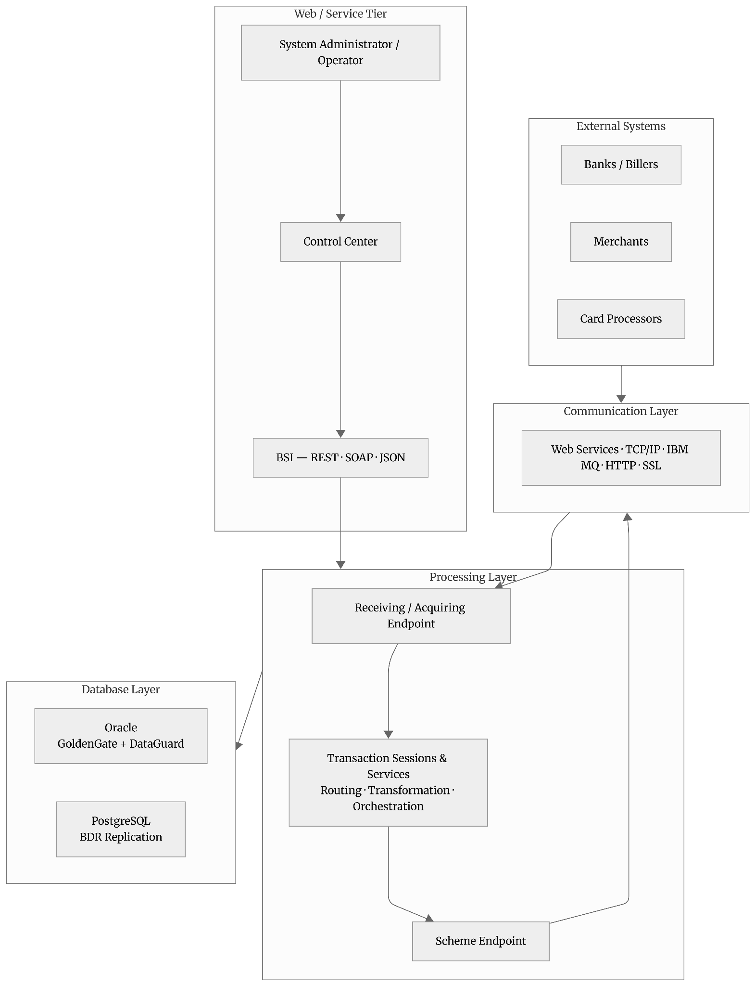
Fig 1: UPF Multi-Tier Architecture
3.3.2 PRM Component Architecture
PRM's architecture is organized into four layers. The Application Layer receives transactions, routes them to Scoring Modules via REST, executes rule processing, writes transactions and alert data to the RT/NRT Database via JDBC, and coordinates the overall fraud assessment lifecycle. Scoring Modules communicate with the Application Layer via REST and maintain their own Scoring Database.
The Data Layer comprises the RT/NRT Database — containing transactions, alerts, demographics, and short-window data — and the Scoring Database used exclusively by scoring modules. The Business Logic Layer is implemented by the Web Application Server, which reads from the RT/NRT Database via JDBC and delivers content to the Presentation Layer via HTTP and Angular. The Presentation Layer consists of a client Workstation accessible via Web UI (Angular-based) or Desktop application, providing fraud analysts with access to the Analysis and Review platform for alert investigation and case management.
PRM processes transactions through two complementary flows — Real-Time (RT) and Near Real-Time (NRT) — each serving a distinct fraud management purpose. In the RT flow, the PRM RT component is positioned between the Issuer Bank Switch and the Core Banking/Host System. When a card transaction originates at a Merchant POS terminal, the Customer Card interacts with the Merchant POS, which routes the transaction through the Acquirer System, BASE24 Switch, and Payment Network to the Issuer Bank Switch. At this point, PRM RT is invoked synchronously. The Issuer Bank Switch sends the transaction to PRM RT; PRM RT scores it via the PSE or USE scoring engine and evaluates real-time fraud rules. PRM RT returns a recommendation: Approve or Decline. This A/D decision feeds into the Core Banking/Host System, which executes the authorization accordingly, and the response is returned through the payment network chain to the merchant terminal. The entire RT cycle must be completed within the authorization window — typically under two seconds end-to-end.
In the NRT flow, which occurs after authorization has been completed, the Issuer Bank Switch forwards the transaction record to PRM NRT for further analytics. PRM NRT performs additional scoring (if configured), executes NRT rules including velocity checks, profile-based rules, and pattern analysis, and writes results to the RT/NRT database. If any rules are triggered, an Alert is generated and surfaced in the PRM Analysis and Review UI. Depending on the bank's configured alert handling workflow, the alert may be assigned to a Bank Analyst for manual investigation or routed to a Dialer System for automated customer outreach. Actions available to the analyst or automated system include blocking the card or account, marking transactions as confirmed fraud, placing accounts under watch, or sending customer notifications. The feedback from analyst actions — such as confirmed fraud or false positive — can loop back to refine future scoring.
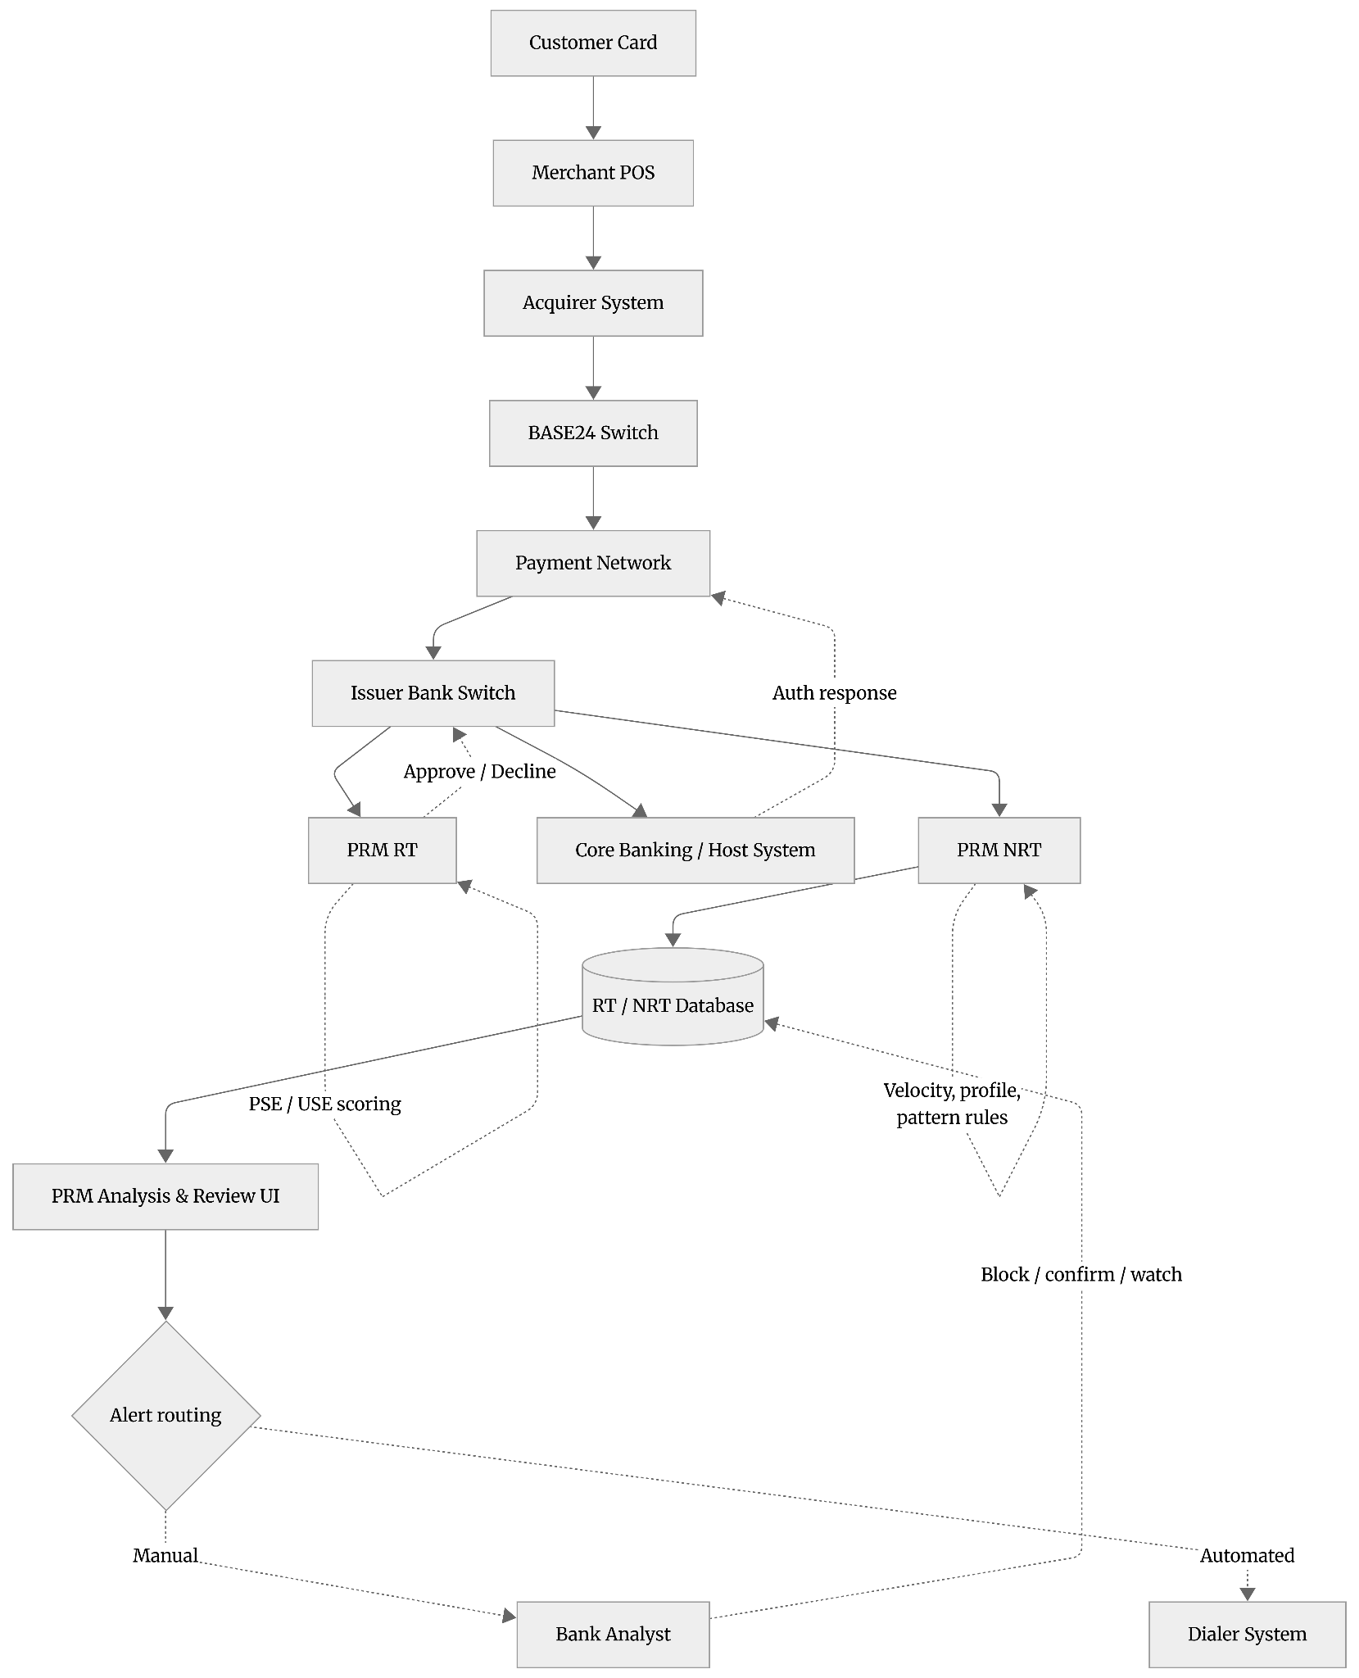
Fig 2: PRM Workflow - RT and NRT flows
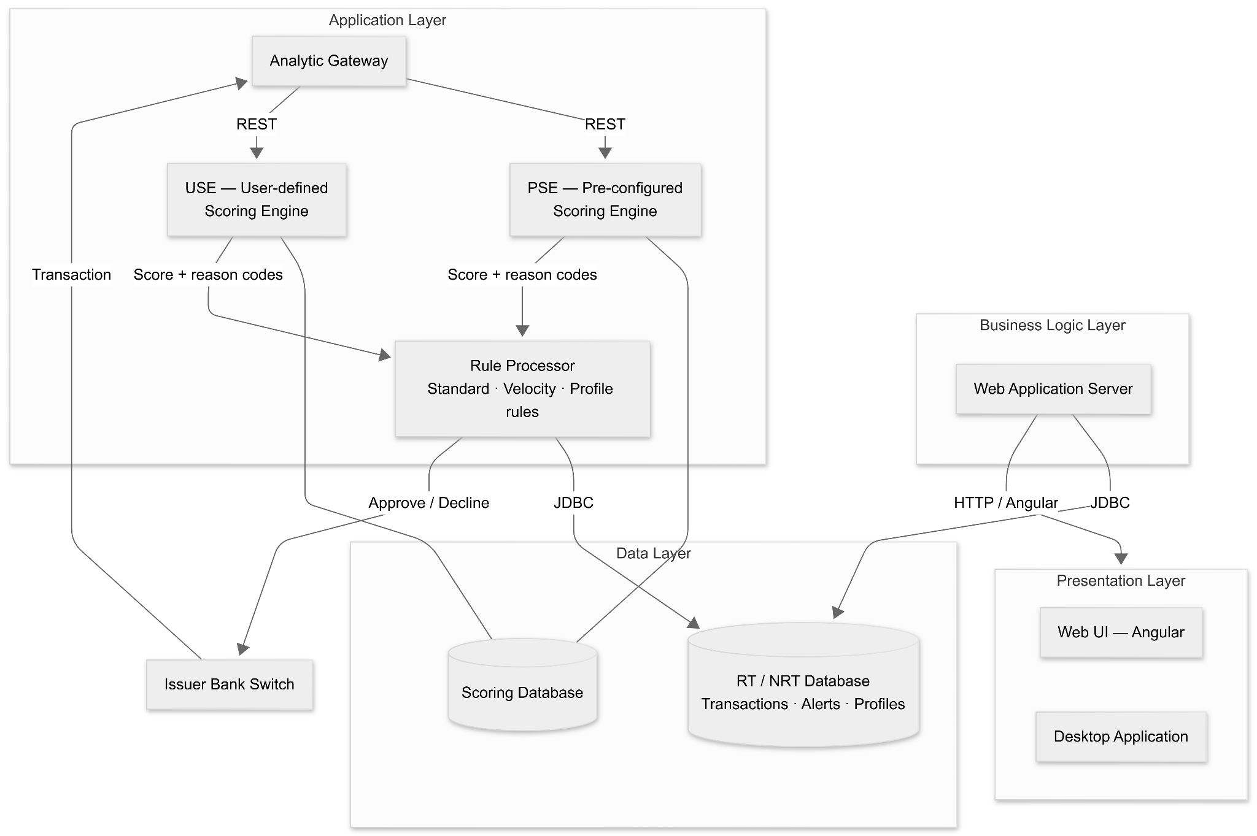
Fig 3: PRM Architecture
3.4 Objectives
The objectives of the methodology and flow analysis phase of the internship were:
- To map and understand the end-to-end UPF transaction processing flow from external system message ingestion through the Communication Layer, Processing Layer, Scheme Endpoint, and back out to the destination system.
- To understand how UPI Pay API and Collect API flows operate, identifying all participating entities — Acquiring Channel, Payer PSP, Payee PSP, UPI, ACI Switch, Remitter Bank Core Banking, UPI HSM, and Beneficiary Bank Core Banking — and the categories of messages exchanged.
- To understand the PRM Real-Time (RT) processing flow, including the synchronous invocation of PRM RT within the authorization chain and the A/D recommendation mechanism.
- To understand the PRM Near-Real-Time (NRT) processing flow, including post-authorization scoring, NRT rule execution, alert generation, and analyst workflow routing.
- To understand the PRM four-layer component architecture and the interactions between the Application Layer, Data Layer, Business Logic Layer, Presentation Layer, and Scoring Modules.

Chapter 4
Implementation and Experimentation
4.1 UPF Implementation — Components and Deployment
The practical implementation of the Universal Payments Framework (UPF) involves the installation, configuration, and coordination of multiple interdependent components that together enable seamless payment processing. UPF supports three primary installation modes: processing-only deployments, web and service tier deployments, and the Integrated Installation, which is the recommended approach as it deploys both processing and service tiers together. The integrated model simplifies deployment, reduces configuration overhead, and ensures better synchronization between processing and management components.
Table 2: UPF Traditional vs Cloud-Native Deployment Models
Feature | Traditional (Non-containerized) | Cloud-Native (Kubernetes-based)
Deployment unit | Application server instances | Containers / Pods
Scaling | Vertical / manual horizontal | Horizontal auto-scaling
Infrastructure | Bare metal or VM | Kubernetes cluster
High availability | GoldenGate / DataGuard (Oracle), BDR (PostgreSQL) | Kubernetes health checks + rolling updates
Upgrade approach | In-place or rolling per tier | Rolling container image updates
Configuration | Configuration Builder metadata | Configuration Builder metadata
Management UI | UPF Control Center | UPF Control Center

The processing layer plays a critical role in executing payment transactions. It is configured using the Configuration Builder, a design tool that allows payment solution developers to define cartridges. Cartridges are self-contained units of payment logic that encapsulate transaction processing rules, entity definitions, endpoint configurations, message formats, and connectivity parameters. They serve as the primary unit of deployment, versioning, and upgrade within UPF, making the system modular and extensible.
Through Configuration Builder, developers define how different transaction types — such as card payments — are routed, validated, and processed. Once configured, the tool generates metadata that is consumed by the UPF processing engine at runtime. This metadata-driven approach enables high configurability without requiring frequent code changes, which is essential in dynamic payment environments.
An important feature observed during implementation is auto-exposure. Entities defined within Configuration Builder are automatically exposed in the UPF Control Center, generating corresponding user interface pages without additional UI development. This significantly reduces development effort and ensures consistency between backend configurations and frontend management views. Control Center allows administrators and operations teams to monitor transactions, manage configurations, and perform operational tasks efficiently.
Overall, the UPF implementation demonstrated how a universal platform can handle multiple payment types through standardized processing logic, scalable architecture, and centralized management, making it suitable for high-volume, real-time payment processing.
4.2 PRM Fraud Detection Testing and Analysis
The Proactive Risk Manager (PRM) module focuses on identifying, analyzing, and mitigating fraudulent activities in real time. During the internship, practical exposure was gained by observing how transactions are evaluated, flagged, and managed through various fraud detection mechanisms.
4.2.1 Rule Testing
One of the key activities involved studying how fraud detection rules are defined and tested within PRM. Special attention was given to velocity rules, which trigger alerts when many similar transactions occur within a short time frame. For example, multiple transactions from the same card or account within seconds may indicate suspicious behavior. PRM supports multiple rule categories including standard rules (evaluating static transaction attributes), velocity rules (tracking transaction frequency and volume over configurable time windows), and profile rules (comparing current transaction behavior against historical behavioral profiles).
It was observed that rule configuration requires careful threshold selection. Overly strict thresholds can lead to excessive false positives, impacting genuine customers, while relaxed thresholds may allow fraudulent transactions to pass undetected. Testing these rules helped in understanding the balance required between maintaining high security and ensuring smooth customer experience. The internship provided insight into how fraud analysts and rule administrators collaborate to calibrate rule parameters based on observed fraud patterns and business risk tolerance.
Table 3: PRM Rule Categories and Descriptions
Rule Category | Trigger Basis | Example Use Case | Output
Standard rules | Static transaction attributes | Transaction amount above threshold, foreign country transaction | Alert or score adjustment
Velocity rules | Frequency / volume over a time window | More than 5 transactions from same card in 60 seconds | Alert generation
Profile rules | Deviation from historical behavioral profile | Transaction 10× larger than customer average spend | Risk score increase
Real-time (RT) rules | Evaluated synchronously at authorization | Card-not-present transaction with mismatched billing address | Approve / Decline recommendation
Near-real-time (NRT) rules | Evaluated post-authorization | Pattern analysis across multiple accounts | Alert for analyst review

4.2.2 Scoring Engine
PRM uses a scoring engine to evaluate the overall risk associated with each transaction. The Analytic Gateway within PRM routes transactions to Scoring Modules via REST, integrating machine learning-based risk scores into the overall rule evaluation pipeline. PRM supports two types of scoring engines: the Pre-configured Scoring Engine (PSE), which uses ACI's built-in machine learning models, and the User-defined Scoring Engine (USE), which allows financial institutions to plug in their own proprietary models.
During experimentation, sample scoring outputs were analyzed to understand how individual rule outcomes contribute to the final risk score. Each transaction is assigned a numerical score along with reason codes, which explain why a transaction has been flagged as risky. This transparency enables fraud analysts to quickly assess the severity of a transaction and identify the contributing risk factors. The scoring engine therefore plays a critical role in prioritizing alerts and supporting informed and timely decision-making. The mechanism by which the Analytic Gateway routes transactions to Scoring Modules via REST, receives scores and reason codes, and integrates these into rule evaluation demonstrated the practical pattern for embedding ML model inference within a real-time event processing pipeline.
Table 4: PRM Scoring Engine Types - PSE vs USE
Feature | PSE (Pre-configured Scoring Engine) | USE (User-defined Scoring Engine)
Model origin | ACI built-in machine learning models | Institution's own proprietary models
Customization | Configuration only | Full model replacement
Interface | REST via Analytic Gateway | REST via Analytic Gateway
Scoring database | Shared Scoring DB | Separate / institution-managed
Output | Numerical score + reason codes | Numerical score + reason codes
Use case | Out-of-the-box fraud detection | Institutions with in-house ML capability

4.2.3 Alert Handling
The internship provided insight into the fraud analyst workflow within PRM's Analysis and Review (AR) platform. When a transaction crosses a predefined risk threshold, an alert is generated and made available for review in the AR UI. Analysts examine transaction details, customer history, past alerts, and behavioral patterns before taking appropriate action. The AR platform is implemented as a microservices architecture comprising Frontend WAR components, AR REST Backend WARs, and the PRM Backend WAR, all backed by separate databases — the AR DB and the PRM DB with its RT and NRT schemas.
Possible actions include blocking the card, marking the transaction as fraudulent, allowing the transaction, or placing the account under monitoring. This process highlighted the importance of human intervention alongside automated fraud detection systems to reduce false positives and ensure accurate fraud management. The system must balance automation — to handle alert volume at scale — with analyst oversight, to maintain accuracy and satisfy regulatory and compliance requirements. Feedback from analyst actions — such as confirmed fraud designations or false positive markings — can loop back into the scoring system to refine future model performance.
4.2.4 System Integration
Another important aspect explored was system integration. PRM integrates with multiple transaction sources such as card processing systems and payment switches. Real-time communication between systems ensures that fraud checks are performed without introducing significant delays in transaction processing. In the RT flow, PRM is positioned synchronously within the authorization chain between the Issuer Bank Switch and the Core Banking/Host System, requiring sub-second processing latency to remain within the authorization window.
In the NRT flow, PRM receives post-authorization transaction records from the Issuer Bank Switch for deeper analytics, operating asynchronously without the strict latency constraints of the RT path. Additionally, notification mechanisms play a key role in customer communication. Alerts and messages help keep customers informed during fraud checks, enhancing transparency and trust while also supporting regulatory and compliance requirements. The internship also covered how PRM integrates with Dialer Systems for automated customer outreach when alerts are generated.

Chapter 5
Key Learnings from the Internship
5.1 Technical Learnings from UPF
The study of UPF provided foundational technical insights into enterprise payment platform design:
- Multi-Tier Architecture for Payment Processing: UPF's separation of Communication, Processing, Web/Service, and Database tiers reflects rigorous application of separation-of-concerns principles in a high-availability financial system context. Each tier can be independently scaled and upgraded, minimizing systemic risk during maintenance operations.
- High Availability and Disaster Recovery Design: Understanding the role of GoldenGate and DataGuard for Oracle, and BDR replication for PostgreSQL, illustrated how enterprise payment databases achieve active-active or active-passive replication across multiple sites. The concept of Distributed Endpoint Mode — spreading endpoint workloads across multiple UPF instances — provided insight into horizontal scaling strategies for payment systems.
- Protocol and Integration Diversity: UPF's support for Web Services, TCP/IP, IBM MQ, HTTP, SSL, SOAP, REST, and JSON across its communication and BSI layers reinforced the reality that enterprise financial systems must bridge a heterogeneous landscape of legacy and modern protocols, often within the same deployment.
- Metadata-Driven Development: The cartridge-based architecture of UPF, where Configuration Builder generates metadata consumed by the runtime engine, demonstrated the power of declarative, metadata-driven approaches in reducing development effort and increasing system configurability without code changes.
- Operational Visibility: The role of the Control Center as a centralized management and monitoring interface, and the auto-exposure feature that automatically generates UI pages from configuration metadata, provided insight into how enterprise platforms balance configurability with operational manageability.
5.2 Technical Learnings from PRM
The study of PRM provided deep insights into fraud management system design and data-driven risk management:
- Real-Time vs. Near-Real-Time Processing: The architectural distinction between PRM RT (synchronous, authorization-stage, sub-second latency requirement) and PRM NRT (asynchronous, post-authorization, richer analytics capability) illustrated a fundamental trade-off in fraud detection system design. RT processing prioritizes speed and availability; NRT processing prioritizes analytical depth. The two modes are complementary, not competing.
- Hybrid Fraud Detection: The combination of rule-based detection (standard rules, velocity rules, profile rules) with machine learning scoring (PSE/USE) demonstrated the superiority of hybrid approaches over purely rule-based or purely model-driven detection. Rules provide explainability and regulatory auditability; ML scores capture complex, non-linear patterns that rules cannot express.
- Microservices in Practice: PRM's decomposition into Frontend WARs, AR REST Backend WARs, and PRM Backend WAR, with separate databases (AR DB, PRM DB with RT and NRT schemas), provided a practical case study in microservices architecture — specifically the challenges of data partitioning, inter-service communication (REST with Spring/Feign), and frontend modularization (Angular add-ins).
- Fraud Analyst Workflow Design: Understanding how alerts are structured, queued, categorized, and routed to analysts — and how analyst actions feed back into the system — provided valuable insight into the human-in-the-loop aspects of AI-assisted decision support systems. The system must balance automation (to handle alert volume) with analyst oversight (to maintain accuracy and regulatory compliance).
- Scoring Engine Integration: The mechanism by which the Analytic Gateway routes transactions to Scoring Modules via REST, receives scores and reason codes, and integrates these into rule evaluation demonstrated the practical pattern for embedding ML model inference within a real-time event processing pipeline.
- Data Architecture for Fraud Analytics: The separation of the RT/NRT Database (containing transactions, alerts, demographics, and short-window data) from the Scoring Database (used exclusively by scoring modules) illustrated how specialized data stores can be used to optimize both processing performance and analytical capability within a complex financial system.

Chapter 6
Results and Conclusions
6.1 Result
The internship at ACI Worldwide yielded substantial and well-rounded results across both the UPF and PRM solution domains. A comprehensive architectural understanding of the Universal Payments Framework (UPF) was achieved, covering its traditional three-tier deployment model — consisting of the business logic and processing layer, the internal communication handler, the web tier, and the database. The broader integration architecture linking UPF to external entities such as banks, billers, card processors, merchants, and API consumers was also explored in depth.
The roles of individual components — including the internal communication handler for high-availability routing, configuration tools for solution development, monitoring tools for operational visibility, system-administration tools, and metadata-driven UI components — were studied, understood, and documented.
A comprehensive understanding of the Proactive Risk Manager (PRM) platform was also attained. This included its four-layer architecture comprising the application gateway, real-time and analytical databases, business-logic and processing services, and the end-user presentation layer. The dual scoring-engine structure — supporting both built-in machine-learning models and institution-specific models — was analysed in detail. Additionally, complete real-time (RT) and near-real-time (NRT) fraud-analysis flows, integrated with issuer systems and backend banking platforms, were mapped.
The microservices architecture of PRM — including frontend modules packaged within the UI for PRM, backend REST services providing domain-specific APIs, supporting processing services, and dedicated databases — was examined thoroughly.
End-to-end UPI Pay and Collect API flows were traced step-by-step, identifying all actors involved and the different categories of messages exchanged. A clear distinction was made between financial messages that initiate movement of funds and non-financial messages that support authentication or confirmation. The interaction between the UPI infrastructure and the payment switch's routing and overlay services was also mapped and understood.
The conceptual integration between UPF's transaction-processing capabilities and PRM's fraud-risk-management functionalities was established, enabling a holistic perspective of how these platforms together support a complete enterprise-grade payment ecosystem — from transaction initiation, routing, and processing (UPF) to fraud scoring, monitoring, and analyst workflows (PRM).
6.2 Conclusion
This internship provided an invaluable exposure to two major platforms in enterprise financial-technology systems: UPF for payment processing and integration, and PRM for fraud detection and risk management. The experience bridged theoretical knowledge in distributed systems, software architecture, machine learning, and financial technology with their practical application in mission-critical production environments.
UPF represents a mature and flexible platform that has progressed from a traditional three-tier deployment structure to a modern cloud-native environment. Its ability to accommodate multiple payment types, integrate with diverse external systems and communication protocols, and support metadata-driven development makes it a strong foundation for enterprise payment solutions. Its dual deployment model — traditional and cloud-based — reflects the hybrid nature of infrastructure commonly managed by large financial institutions.
PRM complements UPF by delivering a multi-layered fraud-management capability operating both during transaction authorization (real time) and through deeper analytics conducted after authorization (near real time). Its hybrid approach — combining deterministic rules and machine-learning-based scoring — is well-suited for addressing complex and rapidly changing fraud patterns. The microservices architecture supporting the UI for PRM reflects modern engineering practices, offering modularity and adaptability to evolving business needs.
Together, UPF and PRM illustrate the significant engineering investment required to build resilient, secure, and intelligent financial-technology systems at scale. The knowledge gained during this internship provides a strong foundation for future work in financial technology, distributed systems, and applied machine learning.
Key Conclusions:
- UPF provides a standards-aligned, extensible integration framework capable of supporting diverse payment types across both traditional and cloud-native environments, with the business logic and processing layer and the internal communication handler forming the high-availability processing backbone.
- PRM's application gateway serves as the central orchestrator for fraud detection, managing transaction ingestion, scoring, rule evaluation, data handling, and alert creation.
- The dual scoring-engine model provides institutions with both pre-configured machine-learning-based scoring and the flexibility to incorporate their own proprietary models.
- The separation between real-time and near-real-time processing supports a balanced approach between high-speed decision-making and deeper analytical insight, both of which are essential to effective fraud management.
- UPI's architecture, with its separation of payer and payee roles and a central switching entity, effectively supports both push and pull payment initiation through a universal framework.
- PRM's microservices architecture demonstrates how complex fraud-management functions can be decomposed into independently deployable services while still delivering a unified experience through the UI for PRM.
- The combined capabilities of UPF and PRM form a complete end-to-end ecosystem that addresses both operational transaction processing and fraud-risk mitigation for modern financial institutions.
Future Scope:
- Deeper investigation into UPF's cloud-native Kubernetes-based deployment model and how containerization changes operational management, scaling, and upgrade strategies for payment systems.
- Further study of how ML models within PRM's USE scoring engine are trained, validated, and updated in production, and how model drift is detected and mitigated.
- Exploration of UPI 2.0 features and their impact on transaction flow architecture within the ACI Switch environment.
- Analysis of regulatory compliance requirements (PCI-DSS, RBI guidelines) and how UPF and PRM are configured to satisfy these requirements in Indian financial institution deployments.
- Investigation into performance optimization strategies for PRM's RT processing path, including scoring engine latency reduction and database query optimization for sub-second authorization decisions.

Appendix A
Key Concepts
UPF Integrated Installation encompasses the following key component categories:
- Processing Tier: Hosts the MCAS processing instances, Receiving/Acquiring Endpoints, Transaction Sessions and Services, and Scheme Endpoints. This tier handles all business logic execution, routing, and transformation.
- Communication Tier: Manages inbound and outbound connections using protocols including Web Services, TCP/IP, IBM MQ, HTTP, and SSL. Routes messages between external systems and the Processing Tier.
- Web/Service Tier: Hosts the UPF Control Center (UI), administrative tools, and the BSI (Business Service Interface) layer, providing REST, SOAP, and JSON interfaces for external system integration.
- Database Tier: Supports both Oracle (with GoldenGate and DataGuard for HA/DR) and PostgreSQL (with BDR replication) database platforms. Stores configuration metadata, transaction records, and operational state.
PRM Database Schema Overview:
- PRM DB — RT Schema: Stores real-time transaction records, scoring results, and short-window data used during synchronous RT fraud evaluation.
- PRM DB — NRT Schema: Stores post-authorization transaction records, velocity data, behavioral profiles, and NRT rule evaluation results.
- AR DB: Stores alert records, case management data, analyst action history, and workflow state for the Analysis and Review platform.
- Scoring DB: Used exclusively by Scoring Modules (PSE and USE) to store model inputs, scoring results, and scoring-related configuration.

Acknowledgements
I would like to express my sincere gratitude to ACI Worldwide for providing the opportunity to undertake this internship and gain exposure to enterprise-grade payment and fraud management systems. I am thankful to my industry mentor and the engineering teams at ACI Worldwide for their guidance, patience, and willingness to share their domain expertise.
I extend my gratitude to my faculty guide at K. J. Somaiya School of Engineering for their academic guidance and support throughout the internship period. I am also thankful to the Department of Computer Engineering for providing the institutional framework for this semester-long internship.
Finally, I thank my family and friends for their constant encouragement and support throughout this journey.

Name
Roll Number
Department of Computer Engineering
K. J. Somaiya School of Engineering
May 2026

